Project Design Phase
Problem – Solution Fit Template

Date | 18 June 2026
Team ID
Project Name | SHOPEZ : E-Commerce Application
Maximum Marks | 2 Marks

Problem – Solution Fit Template:
SHOPEZ is a MERN-stack E-Commerce Application developed to address the challenges faced by online shoppers while browsing products, managing shopping carts, placing orders, and tracking purchases. Many users experience difficulties due to complex interfaces, insecure transactions, and inefficient order management systems. SHOPEZ provides a secure, user-friendly, and efficient platform that simplifies the entire online shopping process.
Purpose:
• To provide customers with a simple and secure online shopping experience.
• To help users browse products, manage carts, and place orders efficiently.
• To improve customer satisfaction through easy navigation and order tracking.
• To build trust through secure authentication and reliable transaction management.
• To enhance the overall e-commerce experience by solving common shopping challenges.

Template:
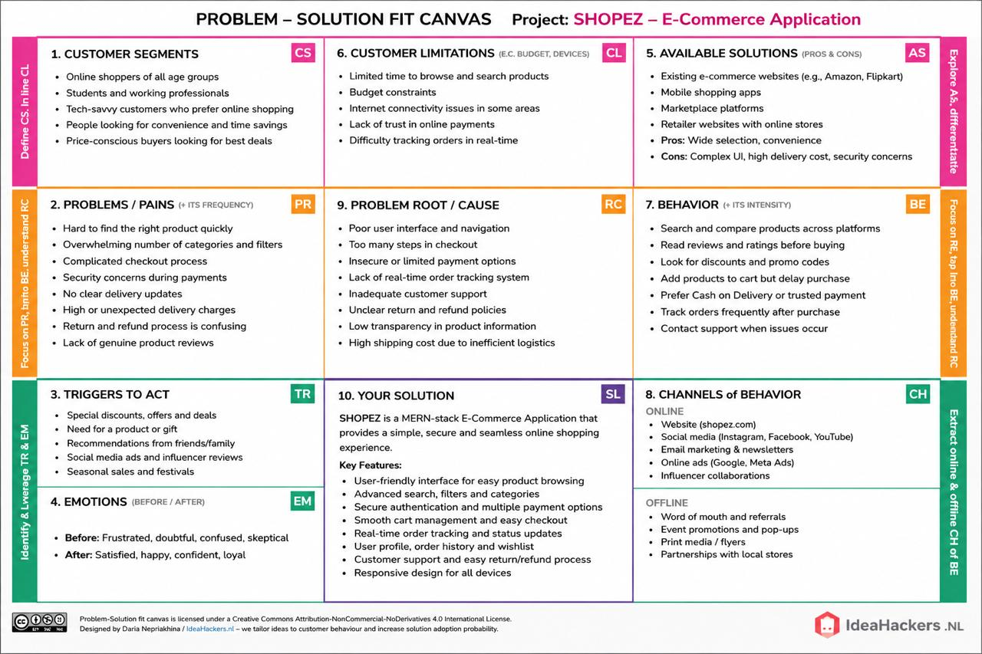
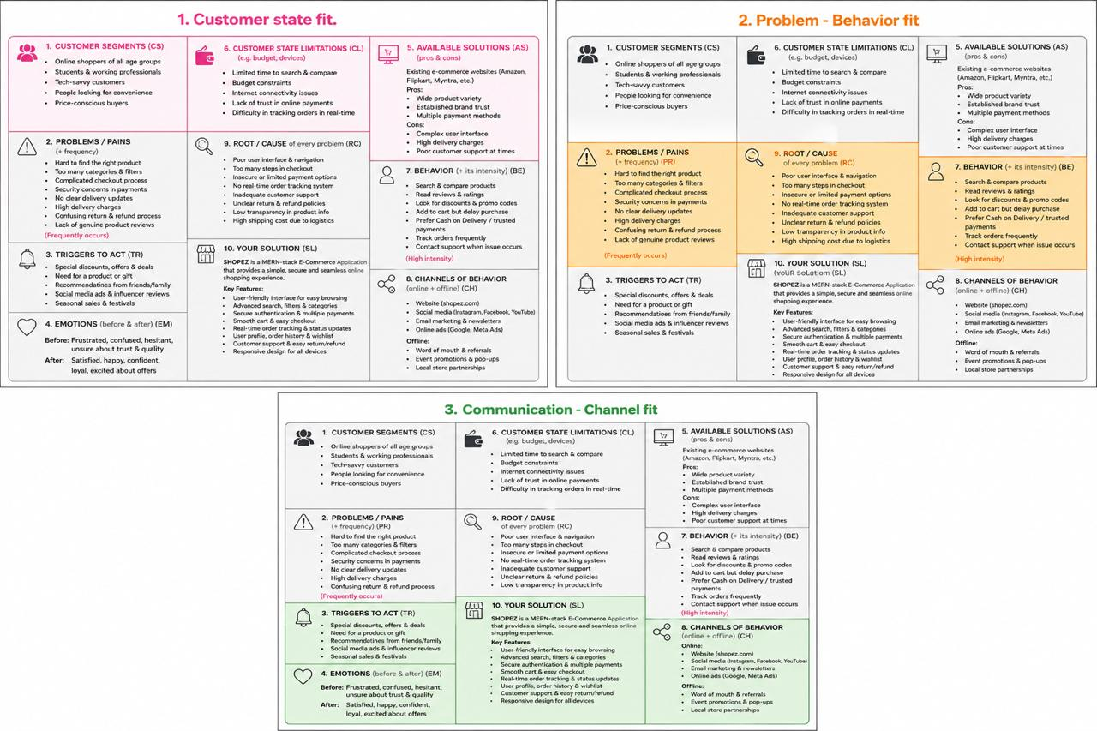
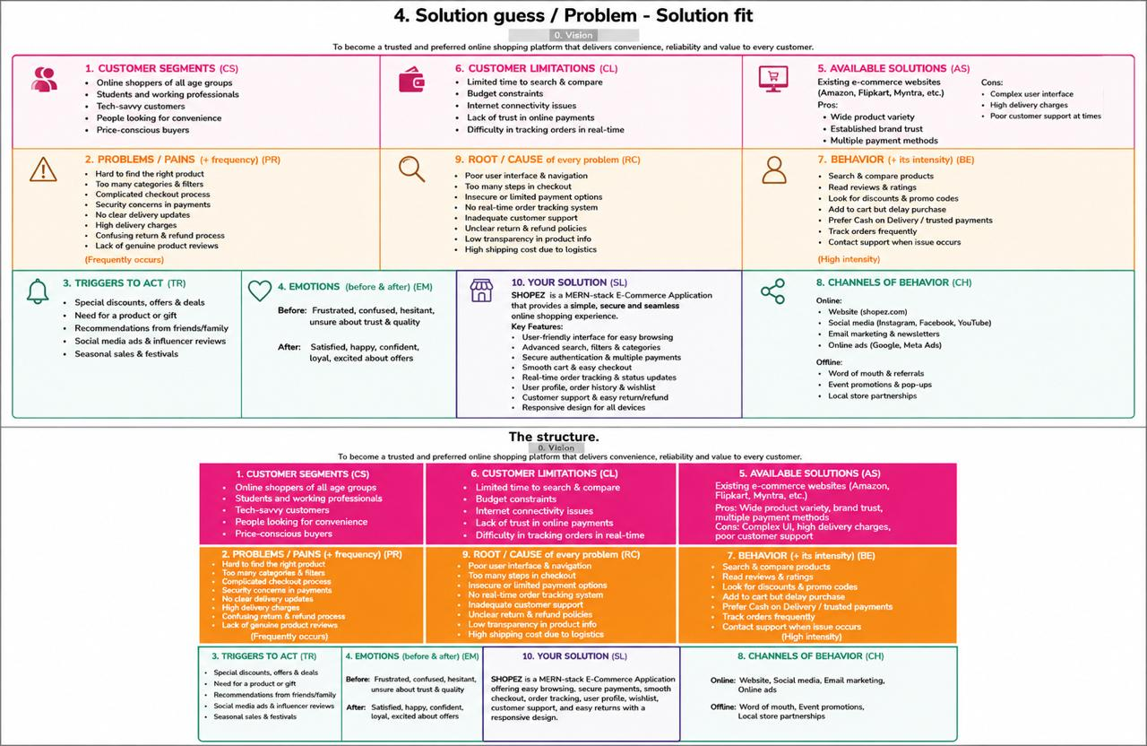
References:
- https://www.ideahackers.network/problem-solution-fit-canvas/
- https://medium.com/@epicantus/problem-solution-fit-canvas-aa3dd59cb4fe

